
INSTALLATION INSTRUCTION

JEEP 4.2 LITER (258 CID)
MULTIPOINT FUEL
INJECTION KIT
P5249610AE For Manual Transmission Vehicles
P5249686AE For Automatic Transmission Vehicles
THIS KIT IS EMISSIONS EXEMPT IN THE STATE OF CALIFORNIA UNDER C.A.R.B. EXECUTIVE ORDER D265-21
THE TUNE UP PROCEDURES AND ENGINE SERVICE ARE THE SAME AS A 1994/1995 4.0 LITER JEEP WRANGLER
PLEASE READ THESE INSTRUCTIONS THOROUGHLY
PRIOR TO INSTALLATION OF THIS KIT
CHECK YOUR PARTS AGAINST THE BILL OF MATERIAL INCLUDED IN THE KIT (Attached to instructions)
This product is intended for use on STOCK, UNMODIFIED, WELL MAINTAINED 1976-1990 4.2 LITER (258 cid.) ENGINES. Installation on engines with MODIFIED CAMSHAFTS, INCREASED COMPRESSION RATIO or engines that are in POOR MECHANICAL CONDITION, such as LOW CRANKING COMPRESSION or EXCESSIVE OIL CONSUMPTION is not recommended.
NOTE: If spark knock (detonation) occurs, it is recommended that 92 octane or better premium fuel be used. The use of Mopar combustion chamber cleaner will reduce carbon deposits and help reduce spark knock.

DISASSEMBLY:
- Disconnect the ground cable from the battery and drain the coolant from the radiator.
- Loosen the power steering pump and the alternator and remove the drive belts. Remove
the two bolts that hold the power steering pump to the water pump. Remove the two
nuts from the rear power steering pump bracket, then slide the pump forward to disen
gage it from the rear bracket. Remove the rear bracket from the intake manifold.
- Remove the air cleaner assembly as a unit and discard it.
- Remove all of the production emissions controls from the engine, including the three (3)
solenoids located on top of the valve cover, the vacuum switch assembly and any lines
and delay valves connected to the carburetor.
NOTE: Refer to the Production Emissions Schematic or to a proper shop manual for your particular year vehicle.
- Remove the pulse air valves, which inject fresh air upstream and downstream of the catalytic converter, and all associated fittings.
- Disconnect the heater hose from the fitting on the intake manifold. Remove the throttle
linkage and throttle cable. Remove the carburetor/intake manifold assembly. This will
require removing the tube that connects the exhaust manifold to the EGR valve mounted
on the intake manifold.
NOTE: It is not necessary to remove the exhaust manifold.
7. Remove the stock mechanical fuel pump and fuel lines from the engine. Make sure to mark the lines PRESSURE and RETURN where you disconnect them at the fender well.
CAUTION: GASOLINE IS HAZARDOUS!! WEAR eye protection and never work on a HOT engine or around FIRE OR FLAME!
- Disconnect the upper and lower radiator hoses and remove the radiator, fan shroud,
engine fan, thermostat housing and crankshaft pulley.
- Remove the plug wires and distributor cap. Remove the #1 spark plug and rotate the
engine in its normal direction until the #1 piston is on the compression stroke. The timing
mark on the dampener should line up with the "0" mark on the timing tab. Looking
through the stock fuel pump mounting boss, rotate the engine backwards until the
camshaft moves and note the amount of slack in the timing chain as degrees on the
timing tab. If the slack is more than 10 degrees, replace the timing chain. Rotate the
engine in the direction of rotation to the "0" of the timing tab. Note the clocked position
of the distributor rotor. Loosen the hold down clamp and remove the distributor.
Remove the ignition coil and bracket and discard them.
- Using a suitable puller, remove the crankshaft dampener. You will need a new dampener, P5249688 for serpentine belt, or P5249687 for V-belt driven pulleys. See Figure 1.

Figure 1
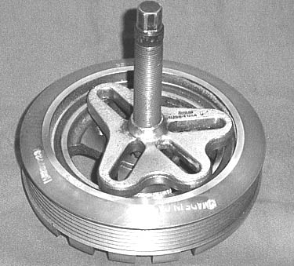

- Remove the brake booster fitting from the old manifold and install it in the new manifold.
- Remove the windshield washer bottle and the charcoal fuel canister. Be sure to mark the vacuum lines that go from the fuel canister to the intake manifold and the fuel tank.
13. Remove the front three (3) driver's side oil pan bolts.
14. Remove the oxygen sensor from the exhaust manifold.
15. If the vehicle has a catalytic converter, it will be necessary to seal the air injection tubes at the CAT and header pipe. Seal by bending the end of the tube and crimping.

ASSEMBLY:
- Install the new oxygen sensor in the exhaust manifold.
- Cut off one end of the tube that went from the exhaust manifold to the EGR valve and
remove the tube nut from it. Install the saucer shaped freeze plug into the hole in the
exhaust manifold where you removed the EGR tube. Secure the freeze plug by tightening
the now free tube nut down against the freeze plug.
- Install the new distributor (The distributor is shipped with an indexing lock pin and will
not rotate. DO NOT REMOVE THE PIN UNTIL THE DISTRIBUTOR IS INSTALLED).
NOTE: If you think the engine may have moved from TDC, make sure the engine is at TDC on the crankshaft balancer (Figure 3). The oil pump should be in the position shown in Figure 4. Install the hold-down clamp and remove the yellow locking pin (Figure 5).

Figure 3
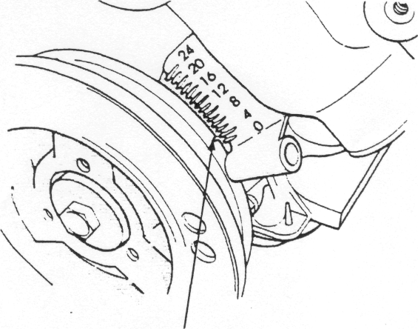
CRANKSHAFT VIBRATION DAMPER TIMING MARK

Figure 4

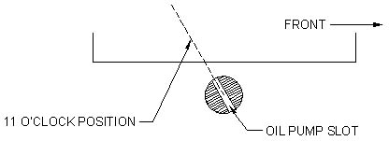

Figure 5
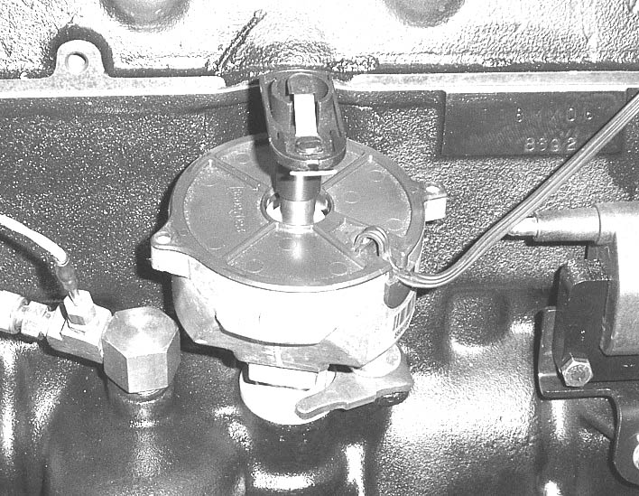
4. Install the combination fuel pump block-off plate/ignition coil bracket where you removed the original fuel pump. Install the coil with the plug wire terminal toward the distributor (Figure 6).
Figure 6
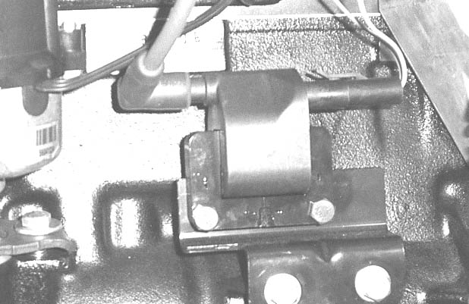

- Install the new crankshaft dampener. (Torque the bolt to 120 ft. Ib.)
- Install the pickup sensor bracket. The bracket bolts to the oil pan where you removed the three (3) bolts in step #13 of the disassembly instructions. Install the pickup sensor on the bracket with the bolt provided and adjust air gap. NOTE: There should be between .020" and .060" clearance between the sensor and the crankshaft dampener.
Figure 7

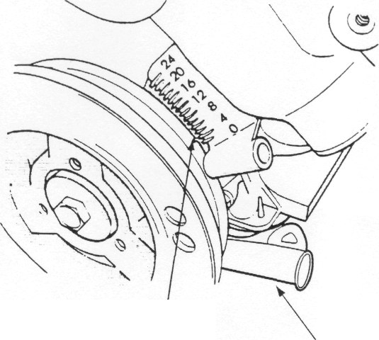
CRANKSHAFT VIBRATION DAMPER TIMING MARK

CRANKSHAFT
SENSOR

7. Install the crankshaft pulley, the fan, and the radiator. Install the new 195 degree thermostat. This is critical. Temperature level of 195 degrees is critical for fuel system operation. Install the coolant sensor supplied into the new thermostat housing in the 3/8" pipe hole, then reinstall this new assembly on the engine. Reinstall the radiator hoses and heater hoses.
- Install the new intake manifold.
- Install the throttle cable and bracket (Figures 9 and 10).

Figure 8 Figure 9
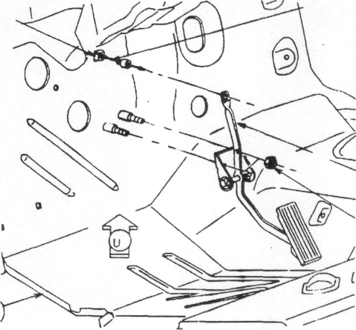

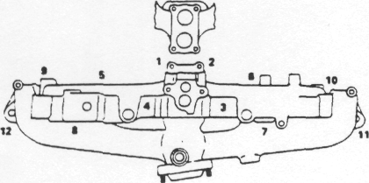
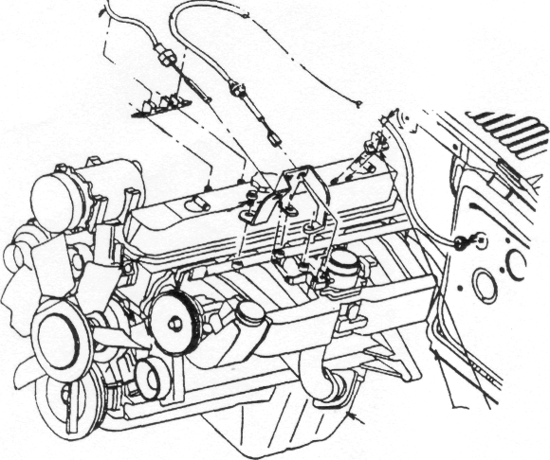
Figure 1O

10. On automatic transmission vehicles: the kick down linkage must be installed (Figures 11, 12 and 13). Once these parts are assembled, you should set the adjustment. Rotate the throttle body to wide open throttle. This will cause the cable to ratchet to the proper zero clearance (Figure 12). At this time, verify that the throttle linkage works smoothly and returns to IDLE (closed throttle).
11. Reinstall power steering pump bracket and belts. Tension the belts. The hole in the bracket may need to be enlarged slightly.

Figure 11
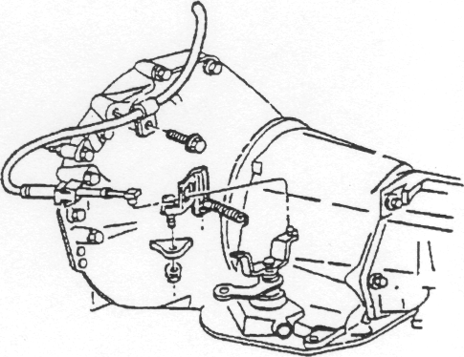

Figure 12
Figure 13

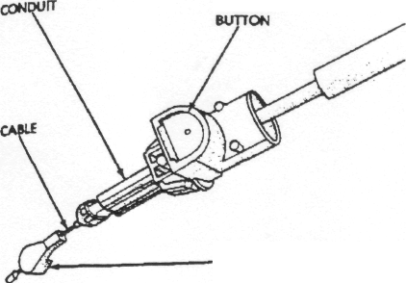
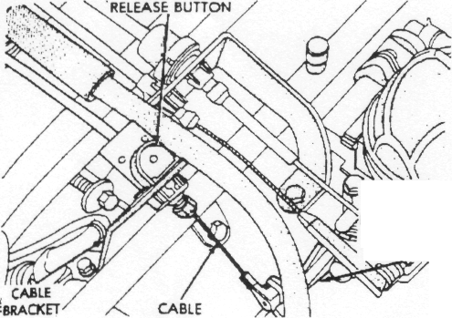

CABLE
CONNECTOR
ROTATE
THROTTLE
BODY LEVER
TO W.O T.
POSITION

12. Connect the new fuel line to the fuel rail and attach to the mounting bracket on the
new intake manifold. Find the fuel inlet line where it was connected to the stock mechanical fuel pump (NOTE: CJ models have the fuel supply line routed down the right passenger side of the vehicle.) Run the line down the frame and under the radiator to the driver's side frame rail. Using a tubing bender you can bend the metal fuel line coming off the fuel rail toward the front of the vehicle. Be careful not to kink the line. Connect the fuel line you just ran under the radiator to the metal line going to the fuel rail.

CAUTION: If you must buy any fuel line to aid in your installation, make sure it is rated to handle EFI pressures! You may also elect to use metal line from the passenger side to your connection on the left frame rail. Secure the line under the radiator with tie wraps.

INSTALL THE FUEL PUMP AS FOLLOWS:
13A. Jack up the rear of the vehicle and place on jack stands. From under the vehicle looking to the rear you will notice a cross member in the frame above and behind the axle housing. On the driver's side of this cross member you will notice a rubber block with three (3) flexible fuel lines emerging from it. The lines turn 90 degrees toward the frame and are connected to hard lines with clamps. On the flange of the cross member are three (3) bolts that attach the fuel tank skid pan to the cross member. (YJ Models only).
13B. Remove the center bolt.
13C. Disconnect the center fuel line from its hard line at the clamp. Reconnect this flexible line to the inlet side of the new pre-filter.
13D. Mount the fuel pump assembly to the cross member flange using the nut and lock washer provided. Connect the pre-filter to the inlet side of the fuel pump using 3/8” fuel hose.
13E. Connect the 3/8" flexible fuel line from the new fuel pump outlet to the inlet of the new fuel filter/regulator. (Bottom 90deg.fitting) Connect the outlet side of the fuel regulator filter to the fuel hard line leading to the engine. Remove the bolt closest to the right side frame rail and mount the fuel pressure regulator unit. Connect the center fitting of the regulator to the fuel return going to the fuel tank. The original fuel return hard line is not used and may be remove or left in place.
14. Install the new vacuum lines to your original emissions canister
(Figures 14, 15 and 16.) Some engines will not have to use both the plastic valve cover
fittings. The many different valve covers have different PCV and fresh air fittings.
Make sure to use the grey fitting in the rear of the valve cover. The stock open vent
located at the front of the valve cover may remain. It is important that the engine is
ventilated to properly to meet emissions and reduce oil leaks caused by crankcase
pressure.
Figure 14
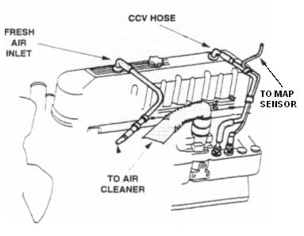

Figure 15

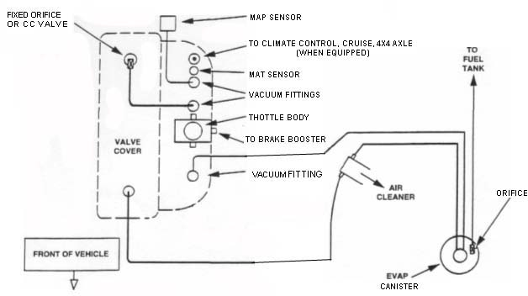
(Not PCV Valve)

Figure 16
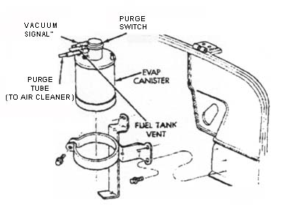

15. Install the new Power train Control Module (PCM) right above the charcoal canister on the bulkhead with the supplied hardware.
NOTE: Some models may vary in the space to mount the PCM, however, it should fit in this approximate location. DO NOT OVERTIGHTEN SCREWS.

16. Plug in the wiring harness into the PCM using the 60-pin connector. DO NOT OVER TIGHTEN THE CONNECTOR! Drape the harness over the top of the master cylinder, then around the back side of the engine.
CAUTION: THE HARNESS MUST NOT BE CLOSE TO THE EXHAUST; USE TIE WRAPS TO SECURE IT OVER THE MASTER CYLINDER (Figure 17).
Figure 17

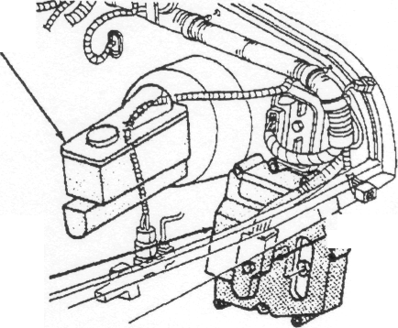
BRAKE MASTER
CYLINDER
60-WAY CONNECTOR
PCM
(LOCATED BEHIND WASHER
FLUID RESERVOIR)

- Find the two relays on the harness a short distance from the PCM. Mount them to the
bulkhead with the screws provided. NOTE: Mount the relays with the wires pointed
down. This is to prevent water build-up within the relays. The PCM may be mounted at
any angle, however, do NOT mount it with the wire connector facing up. This would
allow water to pool in the connector! The PCM is waterproof. The 60-pin connector is
splash proof, but will not work when immersed in water.
- Mount the MAP sensor to the bulkhead right behind the engine with the screws provided.
Plug the green three (3) prong plug from the harness into the MAP sensor (Figure 18).
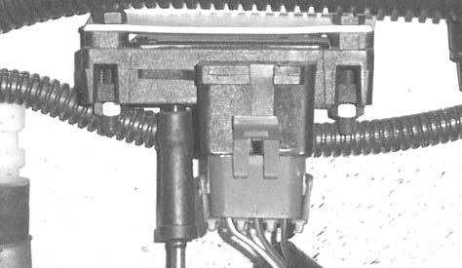
Figure 18

19. Route the harness down along the valve cover toward the front of the engine. Connect the fuel injectors. Each one is marked where it goes.
- In the center of the harness between injector plugs #3 and #4 is a group of four plugs.
Connect three (3) of these to the throttle body in their respective receptacles, and the
fourth one to the Manifold Air Temperature (MAT) sensor (Figure 15).
- In the harness at the front of the engine is another group of three (3) plugs. One of them
is very long; this is the Oxygen Sensor plug. The three (3) prong plug in this group is the
pickup sensor plug. The other (two prong) plug is the coolant sensor plug. These will only
plug in to the correct sensors. Secure the cables with tie wraps provided. Make sure the
pick up sensor connector is tied away from the exhaust manifold.
- Bend the harness toward the passenger side of the Jeep® and down along the spark plug
side of the head. The next plug is the ignition coil connection. Then comes the harness
ground with the distributor plug. Connect the harness ground under the bolt that holds
the dipstick tube to the engine block. (It has other ground wires on it. Do not remove any.)
Connect the distributor.
- Route the rest of the harness along the top of the transmission. The next plug will be the
vehicle speed sensor. (Figure 19.) Route the remaining harness along the frame rail to
the rear of the Jeep® to connect the fuel pump power (+) to the green wire with the black
stripe. The ground wire is brown with an black stripe. Secure the harness all along its length in strategic locations with the tie wraps provided. Make sure that there is clearance between any moving parts or areas of high temperature, such as the vehicle exhaust. You may want to use dielectric grease on the connections to prevent corrosion (Mopar part number J8126688).
Figure 19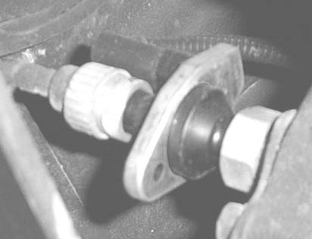

24. To supply a switched 12 volt power supply to the two bulkhead mounted relays, locate the
old positive (+) side coil wire (usually a yellow color). Connect this wire to the relay wire.
Now connect the red relay wire to the starter relay, battery plus(+). The starter relay is
usually located under the battery box or mounted on the fender panel. Mount the
system fuse.
NOTE: Make sure that the switched 12 volt wire is not routed through a ballast resistor or resistance wire. Also make sure that 12 volts are present on this wire during cranking!
- Install the ¼ watt amp diode (supplied) in the field wire of the alternator. This is the smaller of the two wires, usually brown in color, which plugs into the alternator. Cut the wire and install the diode with the pink crimp-on connector facing toward the alternator. It is imperative that this diode be in the field circuit to protect the new electronics.
- You may wish to install a new windshield washer bottle and bracket. These can be
obtained through your local Jeep/Eagle dealer. Washer bottle part number is 55154744;
bracket is 55026288.
- Install the new air filter and bracket. It attaches to the driver's side body support rod.
Connect the two 1/2" hoses to the nylon fittings on the aluminum adapter to the valve cover vent and the fuel canister vent line using the two supplied hoses. (Figure 20).
Figure 2O
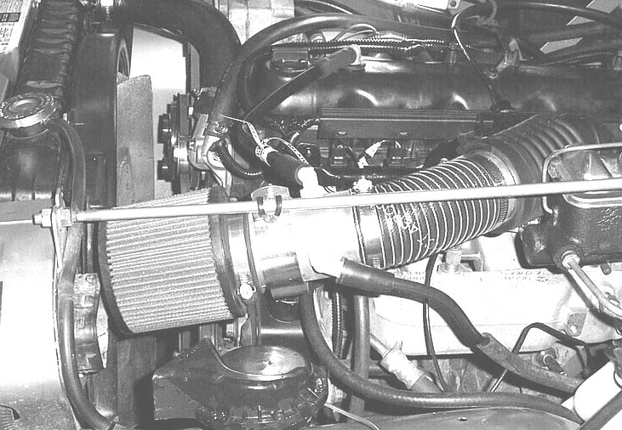
- OPTIONAL: If you wish to install a tachometer or an engine light, the wires for these are already in the harness, located close to the relays. They will be hanging out of the harness. The tachometer wire is light gray with a yellow stripe. This is the tachometer trigger wire. The O.E. 81-86 Jeep® tachometer WILL NOT work with this system. The tach wire switches a 5V signal two times per engine revolution. Set your after market tach on the 4-cylinder scale to achieve a true RPM reading. Some tachs will not work with this 5V signal, or they may have needle flutter at low RPM. If this is the case, you will have to splice into the coil negative side to operate your tach. If you hook up to the coil, use the 6-cylinder setting on your tach. The coil negative side wire is brown/yellow. (Hook up the tach last, after the engine is running, because some tachs have a low impedance and will short the coil to ground. This will not harm anything, but will prevent the engine from running.)

29. The "check engine light" wire runs directly to the PCM. The PCM grounds this wire to turn on a light to display fault codes (Figure 21).
Figure 21
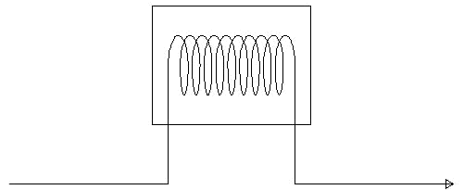
Light Bulb

Switched 12 Volt
12V Black/Violet Wire to ECM

The light bulb holders are available at any local electronics supply.
- On automatic transmission Jeeps, the brown wire that is coiled near the PCM connector
must be connected to the neutral safety switch. This wire can be connected to the bottom
of the starter relay, or to the center terminal on the neutral safety switch. On Chrysler
automatics, this is the center terminal. If you choose to connect it to the starter relay,
make sure that the terminal is for the neutral start switch. It should be grounded in park
and neutral. This wire is for improved idle quality when in "Drive."
- Reconnect the battery and turn on the ignition key. You should hear the electric fuel
pump run for a few seconds and then shut off. Start the engine and IMMEDIATELY
CHECK FOR FUEL LEAKS. Depending on the ambient temperature, the idle RPM may be
high initially, and decrease as the engine warms up. This is normal!! Do not try to adjust
the RPM by changing the opening of the throttle blade. Test Drive! Recheck all connec-tors and fuel lines!
32. Be sure to apply the CARB E.O. and the vacuum routing decals supplied in the kit in a visible location under the hood. CARB exemption info for this kit is at: http://www.arb.ca.gov/msprog/aftermkt/devices/amquery.php
Any parts shortages should be reported to Bennie at Hurley Engine Service Co. 205-323-3136

04/10
We have found the labels depicting which connector goes to which injector can become dislodged in shipping. Below is a list of the connectors and their perspective injector number.

Injector Wire Colors
#1 injector WT/DB
#2 Injector TAN
#3 Injector YELLOW/WT
#4 injector LT BLUE/BRN
#5 injector PINK/BLK
#6 injector GRN/BLK
All the connectors will have a common 12V green wire with a tracer. The second color listed above depicts it’s position.

Refer to the picture on page 16 for the installation of the new style fuel regulator. Place it in the same position as the old style regulator. The fuel pump and filter install in the same position.
CJ vehicles will have the fuel line to the engine ran down the passenger frame rail to avoid the exhaust.

